

# 

### Semester One Examination, 2020

### Question/Answer booklet

# MATHEMATICS

**SOLUTIONS**

**APPLICATIONS**

**UNIT 3**

## Section Two:

## Calculator-assumed

|  |  |  |  |  |  |  |  |  |  |  |
| --- | --- | --- | --- | --- | --- | --- | --- | --- | --- | --- |
| WA student number: In figures |  |  |  |  |  |  |  |  |  |  |

In words

Your name

|  |  |
| --- | --- |
| Number of additional answer booklets used (if applicable): |  |

## Time allowed for this section

Reading time before commencing work: ten minutes

Working time: one hundred minutes

## Materials required/recommended for this section

***To be provided by the supervisor***

This Question/Answer booklet

Formula sheet (retained from Section One)

***To be provided by the candidate***

Standard items: pens (blue/black preferred), pencils (including coloured), sharpener,  
correction fluid/tape, eraser, ruler, highlighters

Special items: drawing instruments, templates, notes on two unfolded sheets of A4 paper, and up to three calculators approved for use in this examination

## Important note to candidates

No other items may be taken into the examination room. It is **your** responsibility to ensure that you do not have any unauthorised material. If you have any unauthorised material with you, hand it to the supervisor **before** reading any further.

## Structure of this paper

|  |  |  |  |  |  |
| --- | --- | --- | --- | --- | --- |
| Section | Number of questions available | Number of questions to be answered | Working time (minutes) | Marks available | Percentage of examination |
| Section One: Calculator-free | 8 | 8 | 50 | 52 | 35 |
| Section Two: Calculator-assumed | 13 | 13 | 100 | 98 | 65 |
|  | | |  | **Total** | 100 |

## Instructions to candidates

1. The rules for the conduct of examinations are detailed in the school handbook. Sitting this examination implies that you agree to abide by these rules.

2. Write your answers in this Question/Answer booklet preferably using a blue/black pen.  
Do not use erasable or gel pens.

3. You must be careful to confine your answers to the specific question asked and to follow any instructions that are specific to a particular question.

4. Show all your working clearly. Your working should be in sufficient detail to allow your answers to be checked readily and for marks to be awarded for reasoning. Incorrect answers given without supporting reasoning cannot be allocated any marks. For any question or part question worth more than two marks, valid working or justification is required to receive full marks. If you repeat any question, ensure that you cancel the answer you do not wish to have marked.

5. It is recommended that you do not use pencil, except in diagrams.

6. Supplementary pages for planning/continuing your answers to questions are provided at the end of this Question/Answer booklet. If you use these pages to continue an answer, indicate at the original answer where the answer is continued, i.e. give the page number.

7. The Formula sheet is not to be handed in with your Question/Answer booklet.

Section Two: Calculator-assumed 65% (98 Marks)

This section has**thirteen** questions. Answer **all** questions. Write your answers in the spaces provided.

Working time: 100 minutes.

Question 9 (6 marks)

The recursive rule $A_{n+1}=1.0125A_{n}-750, A_{0}=18 000$ can be used to model the repayment of a loan, where $A_{n}$ is the amount owing in dollars after $n$ monthly repayments of $\$750$.

(a) Determine

(i) the initial amount of the loan. (1 mark)

|  |
| --- |
| **Solution** |
| $$A_{0}=\$18 000$$ |
| **Specific behaviours** |
| ✓ correct amount |

(ii) the amount owing after $12$ repayments to the nearest cent. (1 mark)

|  |
| --- |
| **Solution** |
| $$A_{12}=\$11 248.31$$ |
| **Specific behaviours** |
| ✓ correct amount |

(iii) the minimum number of repayments required to reduce the amount owing to no more than $\$5 000$. (1 mark)

|  |
| --- |
| **Solution** |
| $${A_{21}=5481.37, A}_{22}=4799.88$$ Hence require $22$ repayments. |
| **Specific behaviours** |
| ✓ correct number of repayments |

(b) After $12$ repayments, changes to the financial circumstances of the borrower meant that the monthly repayment was halved. Determine the change in the minimum number of repayments required to reduce the amount owing to no more than $\$5 000$. (3 marks)

|  |
| --- |
| **Solution** |
| $$A_{n+1}=1.0125A_{n}-375, { A}_{0}=11248.31$$ $$A_{23}=5046.81, A_{24}=4734.89$$ Now require $12+24=36$ repayments.  Number of repayments has increased by $14$. |
| **Specific behaviours** |
| ✓ shows modified recursive rule  ü new number of payments required  ü states the change in number of repayments |

Question 10 (10 marks)

The table below shows the average lifespan $L$ years and the average adult weight $W$ kg of male dogs for a variety of breeds.

|  |  |  |
| --- | --- | --- |
| Breed | Weight $W$ (kg) | Lifespan $L$ (years) |
| English Setter | $$33.1$$ | $$11.2$$ |
| Jack Russell | $$5.8$$ | $$13.7$$ |
| Saint Bernard | $$43.5$$ | $$8.9$$ |
| Chihuahua | $$2.2$$ | $$15.8$$ |
| Beagle | $$9.5$$ | $$13.1$$ |
| Bullmastiff | $$54.6$$ | $$8.3$$ |
| Golden Retriever | $$31.7$$ | $$11.6$$ |
| Border Collie | $$16.5$$ | $$13.2$$ |
| German Shepherd | $$34.3$$ | $$10.5$$ |
| Spaniel | $$19.4$$ | $$12.4$$ |

(a) Complete the scatterplot below. (2 marks)

|  |
| --- |
| **Solution (a)** |
| See scatterplot |
| **Specific behaviours** |
| ✓ plots at least $3$ points correctly  ü plots all points correctly |

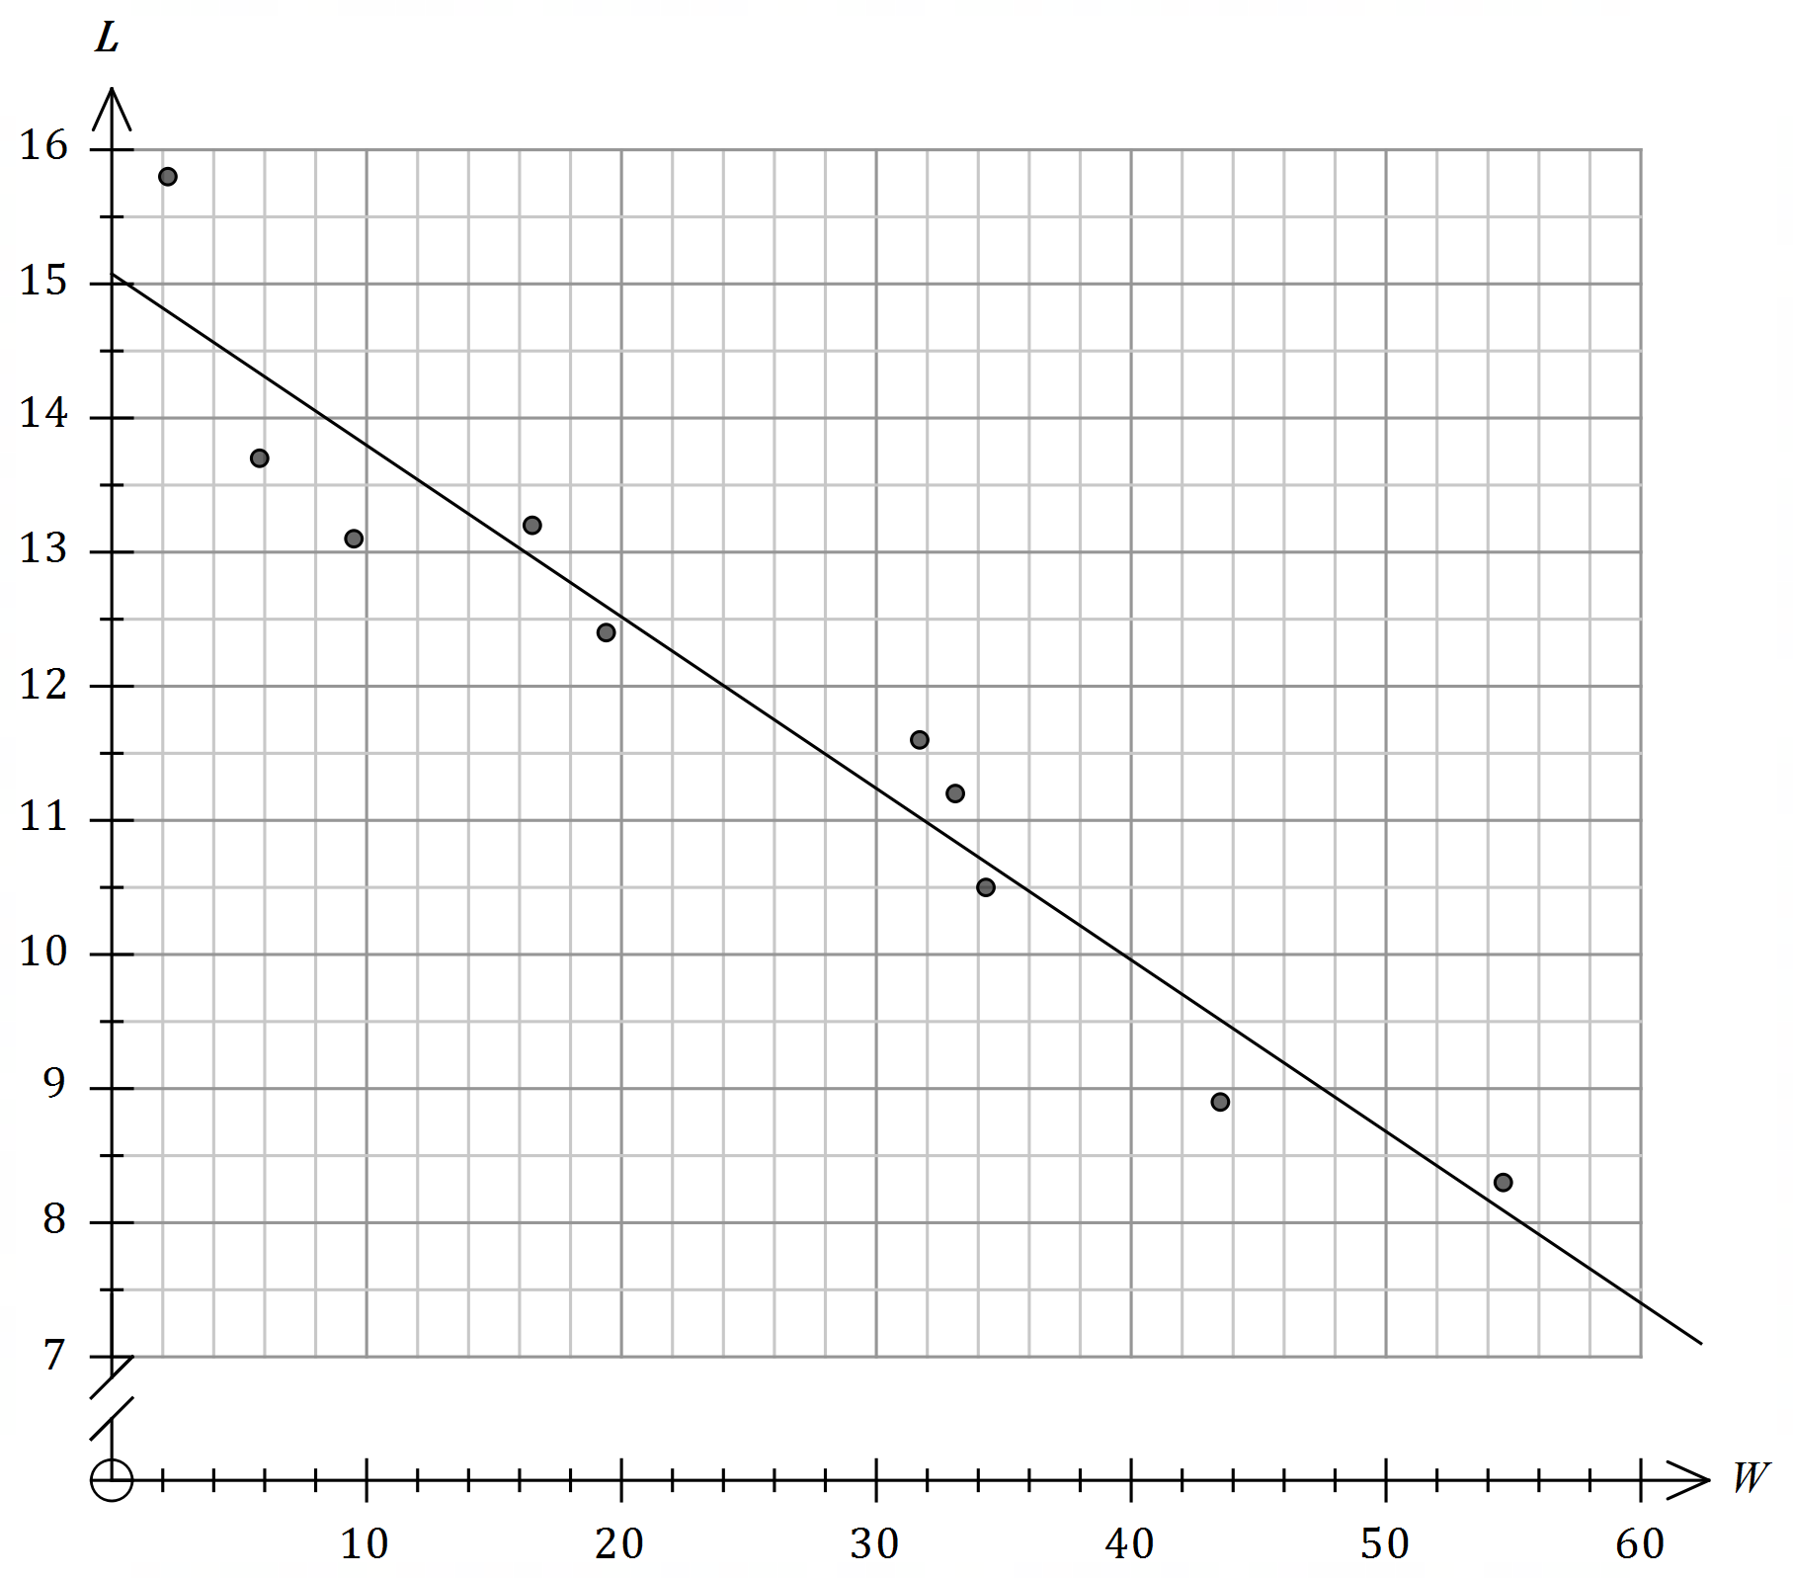

|  |
| --- |
| **Solution (c)** |
| See scatterplot |
| **Specific behaviours** |
| ✓ close to $(8, 14)$ ü close to $(40, 10)$ and uses ruler |

(b) Determine

(i) the correlation coefficient between $W$ and $L$. (1 mark)

|  |
| --- |
| **Solution** |
| $$r=-0.967$$ |
| **Specific behaviours** |
| ✓ coefficient to at least $2$ dp |

(ii) the equation of the least-squares line that can be used to predict $L$ from $W$.

|  |
| --- |
| **Solution** |
| $$L=-0.128W+15.08$$ |
| **Specific behaviours** |
| ✓ coefficients  ü uses correct variables |

(2 marks)

(c) Add the least-squares line to the scatterplot.

(2 marks)

(d) A breed of dog has an average male weight of $52.5$ kg.

(i) Predict the average lifespan of males of this breed. (1 mark)

|  |
| --- |
| **Solution** |
| $$L\left(52.5\right)=8.4 \text{years}$$ |
| **Specific behaviours** |
| ✓ lifespan |

(ii) Briefly discuss two factors that support the validity of your prediction. (2 marks)

|  |
| --- |
| **Solution** |
| Correlation: The strength of the relationship between the two variables is very strong, with $r=-0.967$.  Interpolation: The prediction involves interpolation, since the weight of $52.5$ kg lies between $2.2$ and $54.6$ kg. |
| **Specific behaviours** |
| ✓ indicates strong correlation  ü indicates interpolation |

Question 11 (7 marks)

Six students were asked to create a short presentation to explain the meaning of some graph theory terms. The following table shows which terms each student offered to present.

|  |  |
| --- | --- |
| Student | Terms |
| Fred | Circuit, Walk |
| Grace | Loop, Trail |
| Hazel | Loop, Trail, Edge |
| Joe | Trail |
| Kavan | Walk, Vertex |
| Mia | Edge, Vertex |

(a) Draw a bipartite graph to represent this information. (3 marks)

|  |
| --- |
| **Solution** |
|  |
| **Specific behaviours** |
| ✓ two distinct sets of vertices  ü at least $9$ edges correctly shown  ü all $12$ edges correctly shown |

(b) Determine how many more edges must be added to the bipartite graph in (a) so that it would be a complete bipartite graph. (2 marks)

|  |
| --- |
| **Solution** |
| Complete bipartite will have $6×6=36$ edges.  Already have $12$ edges, so need another $24$ edges. |
| **Specific behaviours** |
| ✓ indicates total edges required  ü correct number to add |

(c) Draw another bipartite graph to show how it is possible to assign each student to present just one term, so that all six terms are explained. (2 marks)

|  |
| --- |
| **Solution** |
|  |
| **Specific behaviours** |
| ✓ all vertices of order one  ü correct pairings |

Question 12 (8 marks)

A random sample of $42$ drivers was taken at a test centre. Each pair of letters shown below represents one driver. The first letter shows the driving test outcome (Pass, P or Fail, F) for the person and the second letter shows if they were taking the test for the first time (Yes, Y or N, No).

FN PN FN FY PY PN PY FY FN PY PN PY PY PN FY PY PN PN FN PN PN

FN FN PY FY PY FN FN FN FY PY FN FN PY FN PN PY PY PN FY FY FN

(a) Two categorical variables have been recorded for each driver. Name one of the variables and explain why it is categorical. (2 marks)

|  |
| --- |
| **Solution** |
| One variable is driving test outcome and it is categorical because the outcomes are categories - pass or fail. |
| **Specific behaviours** |
| ✓ names a variable  ü explains categorical |

(b) Summarise the data by completing the two-way frequency table below. (2 marks)

|  |  |  |
| --- | --- | --- |
|  | Yes | No |
| Pass | $$12$$ | $$10$$ |
| Fail |  |  |

|  |
| --- |
| **Solution** |
| See table |
| **Specific behaviours** |
| ✓ one correct entry  ü all correct entries |

(c) Convert the two-way frequency table to show column percentages. (2 marks)

|  |  |  |
| --- | --- | --- |
| $$\%$$ | Yes | No |
| Pass | $$63$$ | $$43$$ |
| Fail |  |  |

|  |
| --- |
| **Solution** |
| See table |
| **Specific behaviours** |
| ✓ one correct percentage  ü all correct percentages |

(d) Discuss whether this sample data suggests the presence of an association between passing the driving test and taking the test for the first time. (2 marks)

|  |
| --- |
| **Solution** |
| Yes, an association is present. The percentages in the Pass row are quite different, indicating that a higher percentage of drivers pass the test on their first attempt (63%) than if they are repeating (43%). |
| **Specific behaviours** |
| ✓ indicates association present  ü justifies by comparing different row percentages |

Question 13 (7 marks)

In the graph below, the vertices represent towns and the weights on each edge represent the distance, in kilometres, between pairs of towns. A parcel delivery service is based at town D.

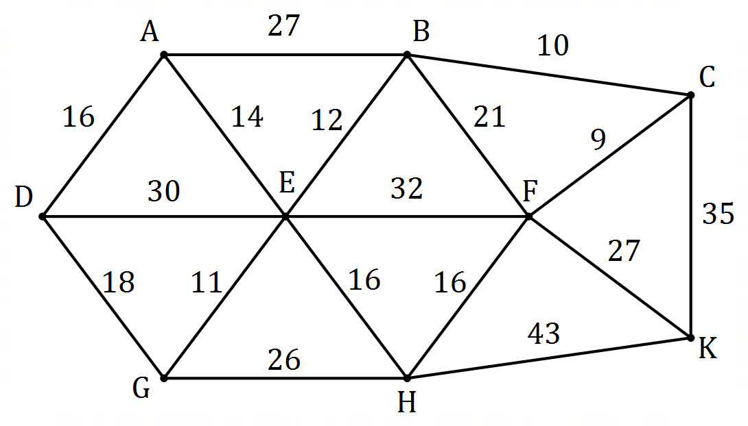

|  |
| --- |
| **Solution (a)** |
| See table |
| **Specific behaviours** |
| ✓ each, round down |

(a) Complete the table below to show the shortest distance $d$ km from town D to each of the other towns. (4 marks)

|  |  |  |  |  |  |  |  |  |
| --- | --- | --- | --- | --- | --- | --- | --- | --- |
| Town | A | B | C | E | F | G | H | K |
| $d$, km | $$16$$ | $$41$$ | $$51$$ | $$29$$ | $$60$$ | $$18$$ | $$44$$ | $$86$$ |

(b) State the route that gives the minimum distance between towns D and K. (1 mark)

|  |
| --- |
| **Solution** |
| D-G-E-B-C-K |
| **Specific behaviours** |
| ✓ correct route |

(c) One day the delivery service has two parcels to deliver, one at A and the other at K. Determine the shortest path from D to K that passes through A and state the length of this path. (2 marks)

|  |
| --- |
| **Solution** |
| D-A-E-B-C-K  Distance is $87$ km. |
| **Specific behaviours** |
| ✓ correct route  ü correct distance |

Question 14 (7 marks)

The graph below shows pressure and altitude readings collected from a variety of sites in a country, together with the least-squares line for the linear association between the variables.

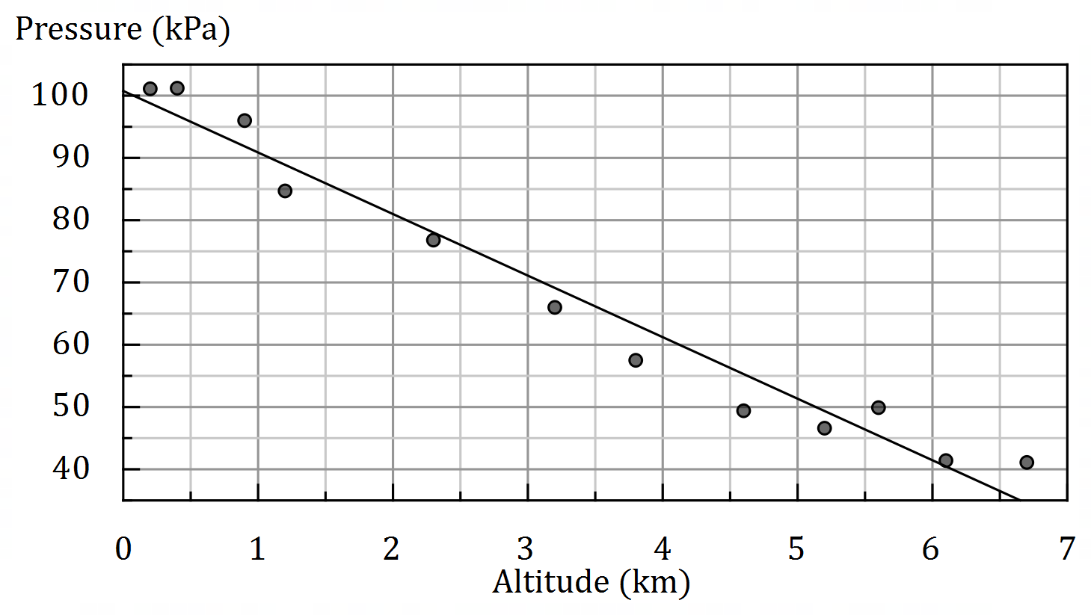

(a) The correlation coefficient $r$ for the linear association is one of the values shown in the list below. Circle this value and justify your choice. (3 marks)

$$\{ -0.98, -0.82, -0.35, 0.03, 0.35, 0.82, 0.98 \}$$

|  |
| --- |
| **Solution** |
| Circles $-0.98$. $r$ must be close to $-1$ to reflect the strong, negative association. |
| **Specific behaviours** |
| ✓ circles correct value  ü indicates negative direction  ü indicates strong association |

(b) Determine the coefficient of determination for the linear association and interpret its value. (2 marks)

|  |
| --- |
| **Solution** |
| $$r^{2}={\left(-0.98\right)}^{2}=0.96$$ $96\%$ of the variation in the pressures at the sites can be explained by the variation in their altitudes. |
| **Specific behaviours** |
| ✓ correct value (decimal or percentage)  ü correct interpretation |

(c) State, with reasons, whether the nature of the relationship between the variables is linear or non-linear. (2 marks)

|  |
| --- |
| **Solution** |
| Non-linear - 'points lie close to a curve' or 'a pattern would be evident in a residual plot for linear model' (+ve residuals, then -ve, then +ve again). |
| **Specific behaviours** |
| ✓ states non-linear  ü reason to support non-linear |

Question 15 (8 marks)

A photocopier was purchased for $\$3 250$. Its value depreciates at a rate of $4.5$ cents per copy. Let $V_{n}$ be the value of the photocopier in dollars after $n$ copies have been made, where $V_{n}=a+bn$.

(a) State the value of the constant $a$ and the value of the constant $b$. (2 marks)

|  |
| --- |
| **Solution** |
| $$a=3250, b=-0.045$$ |
| **Specific behaviours** |
| ✓ value of $a$ ü value of $b$ |

(b) Determine $V_{400}$. (1 mark)

|  |
| --- |
| **Solution** |
| $$V_{400}=3250-0.045×400 \\ =\$3 232$$ |
| **Specific behaviours** |
| ü correct value |

(c) Determine $n$ when $V_{n}=2647$. (2 marks)

|  |
| --- |
| **Solution** |
| $$2647=3250-0.045n$$ $$n=13 400$$ |
| **Specific behaviours** |
| ✓ correct equation  ü correct value of $n$ |

(d) Calculate the value of the photocopier after $44 000$ copies have been made. (1 mark)

|  |
| --- |
| **Solution** |
| $$V_{44000}=3250-0.045×44000 \\ =\$1 270$$ |
| **Specific behaviours** |
| ü correct value |

(e) The photocopier will be replaced as soon as its value falls below $\$350$. Determine the number of copies the photocopier will make before it is replaced. (2 marks)

|  |
| --- |
| **Solution** |
| $$350=3250-0.045n$$ $$n=64444.\overline{4}$$ Will be replaced after $64 445$ copies. |
| **Specific behaviours** |
| ✓ correct equation  ü correct number of copies |

Question 16 (7 marks)

The scores of a sample of students who sat two tests are shown in the table below.

|  |  |  |  |  |  |  |  |  |
| --- | --- | --- | --- | --- | --- | --- | --- | --- |
| Student | $$1$$ | $$2$$ | $$3$$ | $$4$$ | $$5$$ | $$6$$ | $$7$$ | $$8$$ |
| Test A | $$33$$ | $$22$$ | $$30$$ | $$24$$ | $$17$$ | $$20$$ | $$32$$ | $$31$$ |
| Test B | $$14$$ | $$18$$ | $$14$$ | $$21$$ | $$24$$ | $$19$$ | $$15$$ | $$10$$ |
| Residual | $$1.49$$ | $$-1.49$$ | $$-0.42$$ | $$p$$ | $$1.33$$ | $$-1.76$$ | $$1.85$$ | $$-3.78$$ |

Two students missed Test B and their teacher planned to predict their marks for this test using their scores from Test A and the linear relationship modelled by the least-squares line between the response ($y$) and explanatory ($x$) variables.

The equation is $y=-0.635x+33.46$ and the correlation coefficient is $-0.867$. This equation was used to determine the residuals shown in the table above.

(a) Determine the value of $p$ in the table above. (2 marks)

|  |
| --- |
| **Solution** |
| $$y=-0.635\left(24\right)+33.46=18.22 \\ p=21-18.22=2.78$$ |
| **Specific behaviours** |
| ✓ correct value of $y$ ü correct residual |

(b) Construct a residual plot for the data on the axes below. (2 marks)

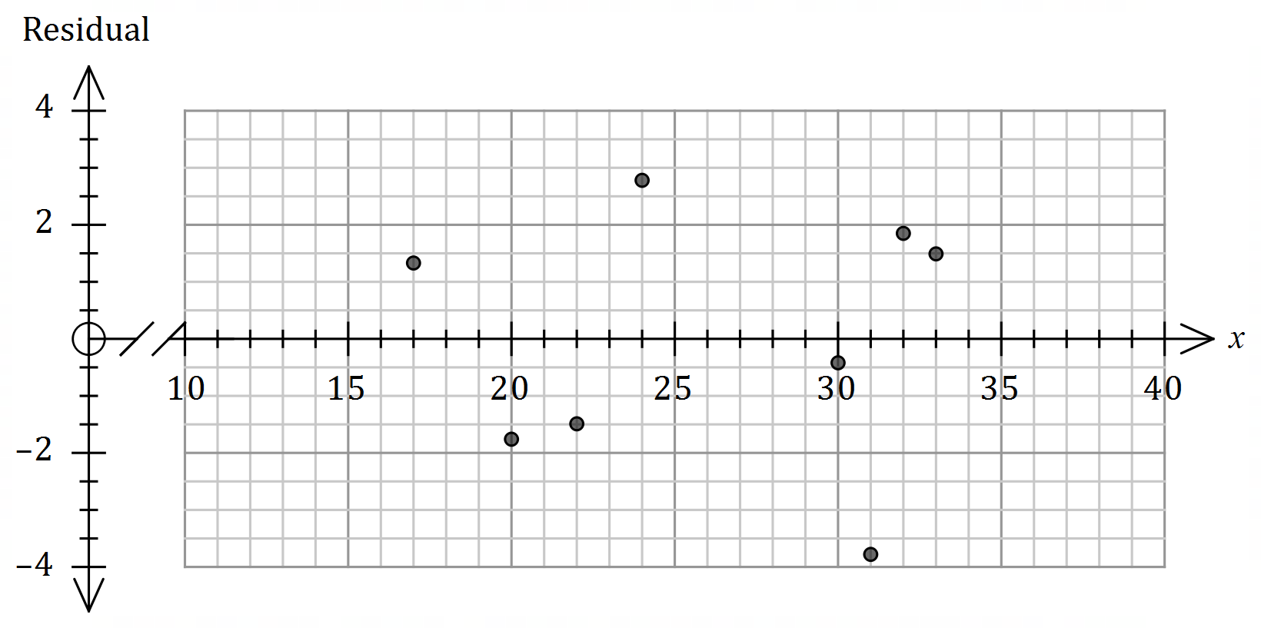

|  |
| --- |
| **Solution** |
| See graph |
| **Specific behaviours** |
| ✓ at least $6$ plotted  ü all accurately plotted |

(c) Using the residual plot and other relevant factors, comment on the teacher's plan.

(3 marks)

|  |
| --- |
| **Solution** |
| The teachers plan is sound as  (i) no pattern evident in residuals and so use of linear model is appropriate.  (ii) the linear relationship is strong, with $r=-0.867$ However, the scores of the missing students in Test A are unknown. If they are not between $17$ and $33$ then the predictions for Test B will involve extrapolation and should be treated with caution. |
| **Specific behaviours** |
| ✓ indicates no pattern in residuals is good  ü indicates strong correlation is good  ü indicates possible danger of extrapolation |

Question 17 (8 marks)

The value $T_{n}$, in dollars, of a property $n$ years after it was bought can be represented by the rule $T_{n+1}=1.079T_{n}, T_{0}=450 000$.

(a) State the value of the property when it was bought and the annual percentage increase in its value. (2 marks)

|  |
| --- |
| **Solution** |
| Initial value: $\$450 000$.  Percentage increase is $0.079×100=7.9\%$. |
| **Specific behaviours** |
| ✓ initial value  ü percentage increase |

(b) Determine the value of the property after $2$ years.

(1 mark)

|  |
| --- |
| **Solution** |
| $$T_{2}=\$523 908.45$$ |
| **Specific behaviours** |
| ✓ correct value |

(c) Determine, to the nearest year, how long it will take for the value of the property to approximately double. (2 marks)

|  |
| --- |
| **Solution** |
| $$2×\$450 000=\$900 000$$ $$T_{9}≈\$892 000, T_{10}≈\$963 000$$ Hence value will double after $9$ years. |
| **Specific behaviours** |
| ✓ indicates value of $T_{9}$ or $T_{10}$ ü correct number of years |

(d) If the annual percentage increase in value of the property changed to $4.4\%$ after $3$ years, determine the value of the property $8$ years after it was bought. (3 marks)

|  |
| --- |
| **Solution** |
| $$T_{3}=\$565 297.22$$ $$T_{n}=T_{n}×1.044, T_{0}=565 297.22$$ $$T_{5}=\$701 099$$ |
| **Specific behaviours** |
| ✓ value after $3$ years  ü indicates new rule  ü correct value (to nearest dollar) |

Question 18 (8 marks)

A warehouse has dividing walls that split its interior into six areas, as shown in the plan below. The gaps in the dividing walls are doorways that allow people to move from one area to another.

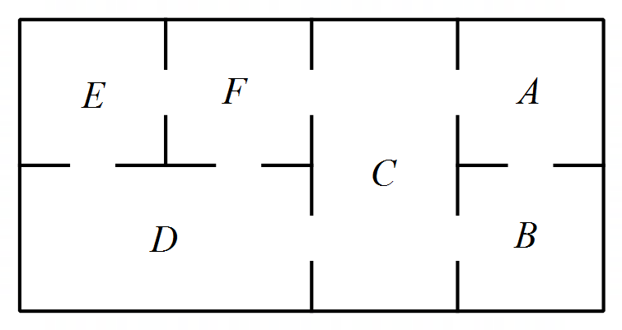

(a) Construct a graph to represent the warehouse areas and doorways, with each area being a vertex and each doorway an edge. (2 marks)

|  |
| --- |
| **Solution** |
|  |
| **Specific behaviours** |
| ✓ connected graph, $6$ vertices, labels  ü correct graph |

(b) An inspector started in one area and followed a route that went through all doorways exactly once before stopping in another area. State where their route started and stopped and explain how the Eulerian properties of the graph in (a) help to identify these locations.

(3 marks)

|  |
| --- |
| **Solution** |
| Start at $F$ and stop at $D$ (or reverse).  The graph is semi-Eulerian, which means that the graph contains an Eulerian trail but not an Eulerian circuit - hence start at one odd vertex and stop at the other. |
| **Specific behaviours** |
| ✓ correct endpoints  ü states graph is semi-Eulerian / has Eulerian trail  ü indicates use of odd vertices |

(c) Another inspector wishes to start in an area, follow a route that visits all the other areas exactly once and end up back where they started. Comment on whether this is possible, referring to the Hamiltonian properties of the graph in (a) to justify your response.

(3 marks)

|  |
| --- |
| **Solution** |
| Not possible.  The graph is semi-Hamiltonian, which means that the graph contains a Hamilton path but not a Hamilton circuit - hence can visit all areas (vertices) just once but unable to return to start. |
| **Specific behaviours** |
| ✓ states not possible  ü states graph is semi-Hamiltonian / has Hamilton path  ü explains meaning of semi-Hamiltonian |

Question 19 (7 marks)

The average mid-year commuting times for full-time workers in Perth ( $p$ minutes) and Sydney  
( $s$ minutes) between the years $2004$ ($t=4$) and $2011$ ($t=11$) are shown in the table below.

|  |  |  |  |  |  |  |  |  |
| --- | --- | --- | --- | --- | --- | --- | --- | --- |
| Year, $t$ | $$4$$ | $$5$$ | $$6$$ | $$7$$ | $$8$$ | $$9$$ | $$10$$ | $$11$$ |
| Perth, $p$ | $$24.2$$ | $$25.8$$ | $$27.2$$ | $$26.1$$ | $$27.7$$ | $$27.1$$ | $$30.2$$ | $$29.5$$ |
| Sydney, $s$ | $$34.2$$ | $$34.7$$ | $$35.1$$ | $$35.8$$ | $$35.6$$ | $$36.2$$ | $$36.7$$ | $$36.5$$ |

The least-squares line to model the linear relationship between $t$ and $s$ is $s=0.348t+33.0$ and $r_{ts}=0.966$.

(a) Determine the least-squares line to model the linear relationship between $t$ and $p$ and state the correlation coefficient for this association. (2 marks)

|  |
| --- |
| **Solution** |
| $$p=0.719t+21.8$$ $$r_{tp}=0.902$$ |
| **Specific behaviours** |
| ✓ correct equation, using correct variables  ü correct value of $r$ |

(b) Predict the average commuting times in Perth and Sydney in the year $2021$ and state, with justification, which prediction you are most confident in. (3 marks)

|  |
| --- |
| **Solution** |
| $$p\left(21\right)=0.719\left(21\right)+21.8≈36.9 \text{m}$$ $$s\left(21\right)=0.348\left(21\right)+33.0≈40.3 \text{m}$$ Most confident in prediction for Sydney as correlation is stronger.  OR  Not confident in either, as both involve considerable extrapolation. |
| **Specific behaviours** |
| ✓ correct Perth time  ü correct Sydney time  ü justifies choice |

(c) Predict the year in which the average commuting time will be the same in both cities and comment on how confident you are of this prediction. (2 marks)

|  |
| --- |
| **Solution** |
| $$0.348t+33.0=0.719t+21.8$$ $$t≈30$$ The times will be the same in year $2030$.  Not at all confident in this prediction as it involves considerable extrapolation. |
| **Specific behaviours** |
| ✓ correct year  ü no confidence justified using extrapolation |

Question 20 (7 marks)

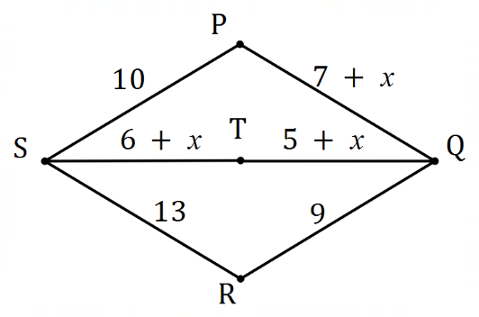The edges in the graph (not to scale) represent roads  
and the weight on each edge is the time, in minutes,  
that it takes to drive along that road. The times to  
drive along $PQ, ST$ and $TQ$ vary throughout the day.

The variable $x$ can only take whole number values.

An inspector wishes to drive along each road at  
least once, starting and finishing at $P$, in the  
minimum possible time.

(a) Briefly explain why the edges on a path between $S$ and $Q$ will have to be repeated.

(1 mark)

|  |
| --- |
| **Solution** |
| $S$ and $Q$ are the only odd vertices. |
| **Specific behaviours** |
| ✓ explanation |

(b) List all possible paths between $S$ and $Q$, and state how long each would take, in terms of $x$ where appropriate. (2 marks)

|  |
| --- |
| **Solution** |
| $SPQ$- time is $17+x$ $STQ$- time is $11+2x$ $SRQ$- time is $22$ |
| **Specific behaviours** |
| ✓ at least two listed and correct  ü all listed and correct |

(c) Determine all possible values of $x$ so that $ST$ would be one of the repeated edges.

(2 marks)

|  |
| --- |
| **Solution** |
| By substitution, $STQ$ takes least time of three paths when: $x=0, 1, 2, 3, 4, 5$. |
| **Specific behaviours** |
| ✓ set of values with no more than $2$ errors  ü correct set of values |

(d) For the case when $x=7$, determine the time required for the inspectors' drive. (2 marks)

|  |
| --- |
| **Solution** |
| $SPQ+STQ+SRQ=24+25+22=71$ Repeat $SRQ$, so an extra $22$.  Total time: $71+22=93$ minutes. |
| **Specific behaviours** |
| ✓ sum of weights  ü correct total time |

Question 21 (8 marks)

A nail is hammered into a piece of wood. The distances moved by the tip of the nail during the first, second and third hits are $16$, $12$ and $9$ mm respectively.

(a) Show that the distances can be modelled by a geometric sequence. (2 marks)

|  |
| --- |
| **Solution** |
| $$r_{1}=12÷16=0.75$$ $$r_{2}=9÷12=0.75$$ Hence the distances have a common ratio and can be modelled by a geometric sequence. |
| **Specific behaviours** |
| ✓ both ratios correct  ü states distances have a common ratio |

(b) Write a rule for the distance moved by the tip of the nail $D_{n}$ during the $n^{th}$ hit of the hammer in the form $D_{n}=a{\left(r\right)}^{n-1}$. (1 mark)

|  |
| --- |
| **Solution** |
| $$D_{n}=16{\left(0.75\right)}^{n-1}$$ |
| **Specific behaviours** |
| ✓ correct rule |

(c) Determine which hit first moves the tip of the nail less than $3$ mm, and state the distance moved during this hit, rounded to one decimal place. (2 marks)

|  |
| --- |
| **Solution** |
| $$D_{6}=3.7969, D_{7}=2.8477$$ On the $7^{th}$ hit, when it moves $2.8$ mm ( $1$ dp). |
| **Specific behaviours** |
| ✓ correct hit  ü correct distance to $1$ dp |

(d) The piece of wood is $60$ mm thick. State, with justification, whether the tip of the nail will pass all the way through the piece of timber, stating any assumptions that you make.

(3 marks)

|  |
| --- |
| **Solution** |
| Yes. The nail will emerge on the ${10}^{th}$ hit as the sum of the first $10$ terms is $60.4$ mm.  Assumptions:  - the nail is longer than 60mm  - geometric sequence will continue  - nail is driven directly through wood, not at angle.  - etc |
| **Specific behaviours** |
| ✓ states yes (with justification)  ü justifies with sum of terms  ü at least one valid assumption |

Supplementary page

Question number: _________

Supplementary page

Question number: _________

Supplementary page

Question number: _________

© 2020 WA Exam Papers. Kennedy Baptist College has a non-exclusive licence to copy and communicate this document for non-commercial, educational use within the school. No other copying, communication or use is permitted without the express written permission of WA Exam Papers. SN245-156-4.